**Java AWT Theory**

**Java AWT** (Abstract Window Toolkit) is *an API to develop GUI or window-based applications* in java.

Java AWT components are platform-dependent i.e. components are displayed according to the view of operating system. AWT is heavyweight i.e. its components are using the resources of OS.

The java.awt package provides classes for AWT api such as TextField, Label, TextArea, RadioButton, CheckBox, Choice, List etc.

Java AWT Hierarchy

The hierarchy of Java AWT classes are given below.

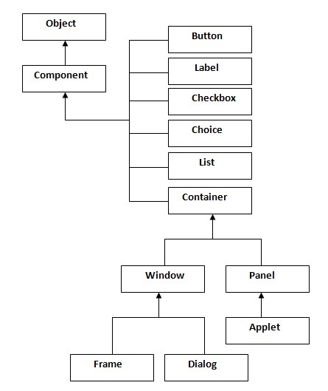

Container

The Container is a component in AWT that can contain another components like buttons, textfields, labels etc. The classes that extends Container class are known as container such as Frame, Dialog and Panel.

Window

The window is the container that have no borders and menu bars. You must use frame, dialog or another window for creating a window.

Panel

The Panel is the container that doesn't contain title bar and menu bars. It can have other components like button, textfield etc.

Frame

The Frame is the container that contain title bar and can have menu bars. It can have other components like button, textfield etc.

Useful Methods of Component class

|  |  |
| --- | --- |
| **Method** | **Description** |
| public void add(Component c) | inserts a component on this component. |
| public void setSize(int width,int height) | sets the size (width and height) of the component. |
| public void setLayout(LayoutManager m) | defines the layout manager for the component. |
| public void setVisible(boolean status) | changes the visibility of the component, by default false. |

Java AWT Example

To create simple awt example, you need a frame. There are two ways to create a frame in AWT.

* By extending Frame class (inheritance)
* By creating the object of Frame class (association)

## **Basic Terminologies**

|  |  |
| --- | --- |
| **Term** | **Description** |
| Component | Component is an object having a graphical representation that can be displayed on the screen and that can interact with the user. For examples buttons, checkboxes, list and scrollbars of a graphical user interface. |
| Container | Container object is a component that can contain other components.Components added to a container are tracked in a list. The order of the list will define the components' front-to-back stacking order within the container. If no index is specified when adding a component to a container, it will be added to the end of the list. |
| Panel | Panel provides space in which an application can attach any other components, including other panels. |
| Window | Window is a rectangular area which is displayed on the screen. In different window we can execute different program and display different data. Window provide us with multitasking environment. A window must have either a frame, dialog, or another window defined as its owner when it's constructed. |
| Frame | A Frame is a top-level window with a title and a border. The size of the frame includes any area designated for the border. Frame encapsulates **window**. It and has a title bar, menu bar, borders, and resizing corners. |
| Canvas | Canvas component represents a blank rectangular area of the screen onto which the application can draw. Application can also trap input events from the use from that blank area of Canvas component. |